**Accept invitation for Events**

I think this is solved.

**Chat is not live**

The chat is not live based you need to refresh the page to get new chat messages

**Picture from Chat**

The pictures sent from the chat get stretched in the preview

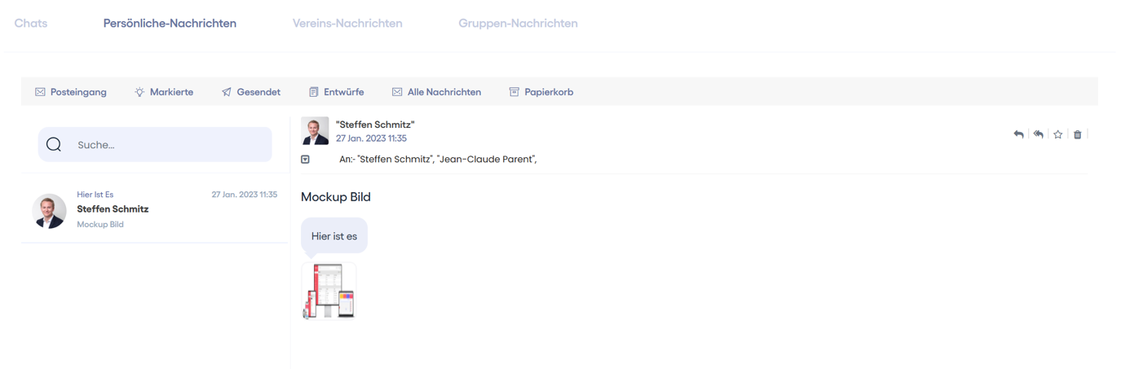

Comment:- we have to checked this

**Bank name Error**

If you enter a bank name it says “Phone number is not valid” at the german language :- Done (Give Language file to client)

**Dashboard**

Please change the german name from „Neuer Artikel“ to „Neuer Beitrag“

Comment:- Done

Web -> Chats, Nachrichten, Termine

Mobil -> Missing

**Sidebar**

Different sidebars for mobile use than for webapp

Comment:- Same as desktop (Pending)

**Message Member_light**

The german word “können” is not displayed correctly.

Comment:- Done

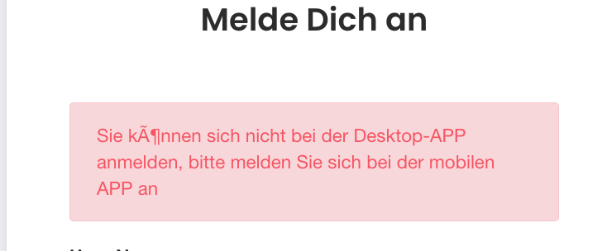

**My profile**

More info is a mandatory field -> change this this to not mandatory

Comment:- Done

**Events**

Delete the Table Field “Date”

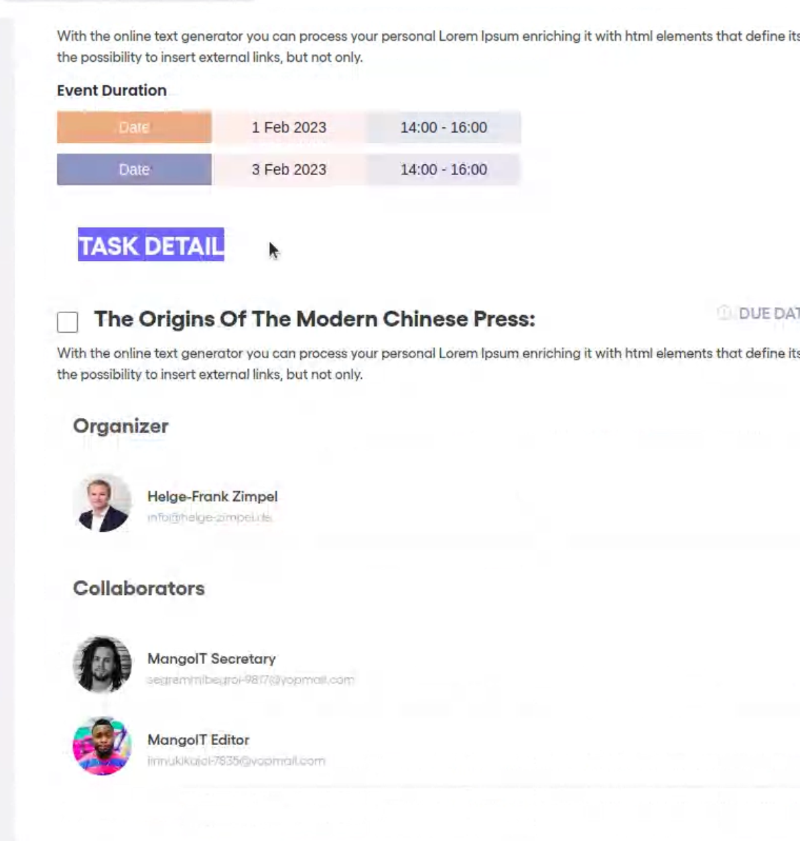

Comment:- Done

**Events, News**

Please change the “options” icon (yellow) to a simple pen like this: 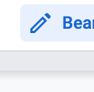



Comment:- Done