1. Set the default language to German.

Comment: Fixed

1. The documents are not visible properly and the description is missing.

If you try to open it, it says “Downloading” but never gets finished.

Comment: Fixed

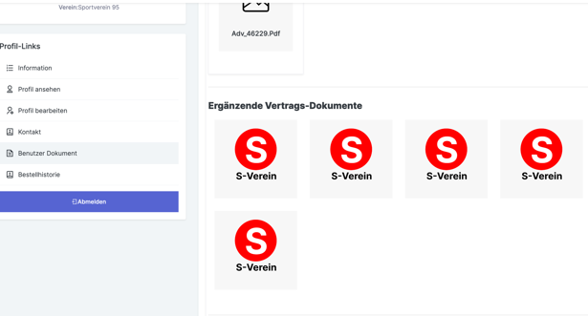

1. In case the API to the club administration is not working. How is it possible to fetch those data?

Are they hardcoded?

Comment: Yes it is hardcoded

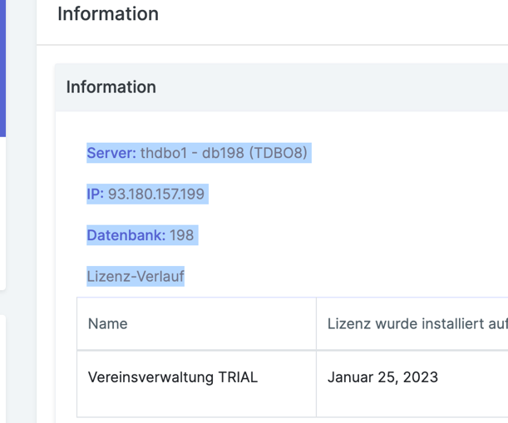

1. Ad a Captcha for the registration fields

Comment: Fixed

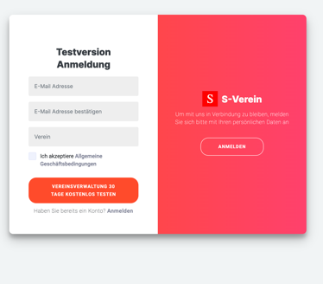 Ein Bild, das Text enthält.

1. API for creating a club administration is not working.

Comment: Fixed

Ein Bild, das Text enthält.

1. Please delete the S-Verein name and Logo, please use the verein.cloud logo and name instead.

Comment: Fixed

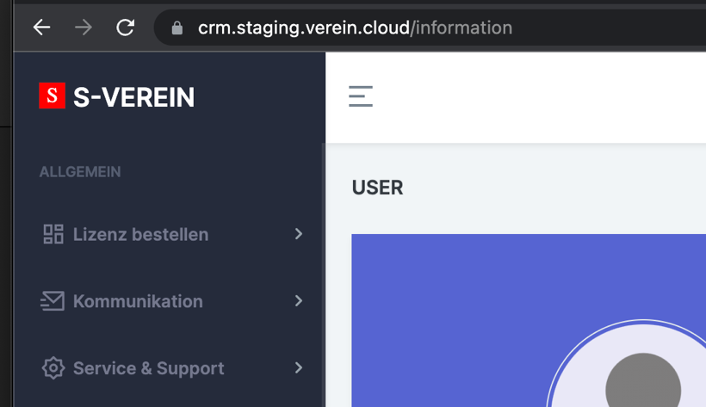

Put the verein.cloud logo in the middle of the screen as in the webapp

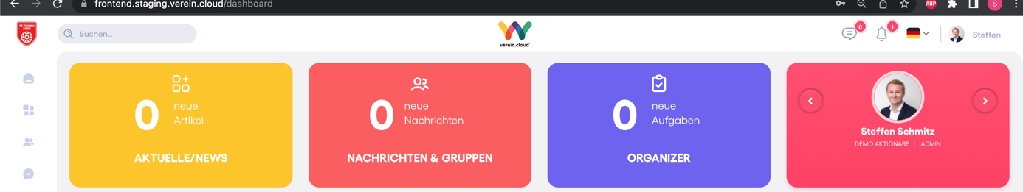

1. Please delete the Switzerland

Comment: Fixed

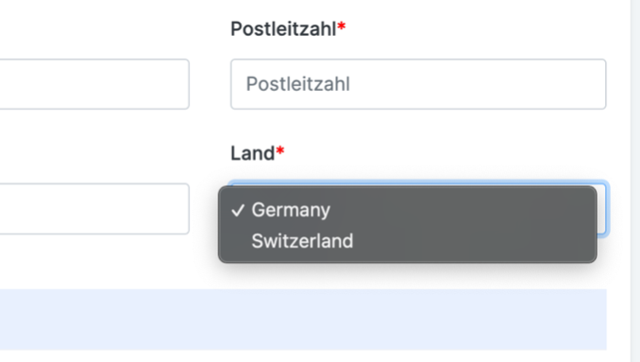

1. Please make it possible that the checkbox is not able to undo. With the registration the user accepts the terms and conditions. This should not be possible to undo.

Comment: Fixed

Ein Bild, das Text enthält.

1. Please delete the delete the Order field.

Comment: Fixed

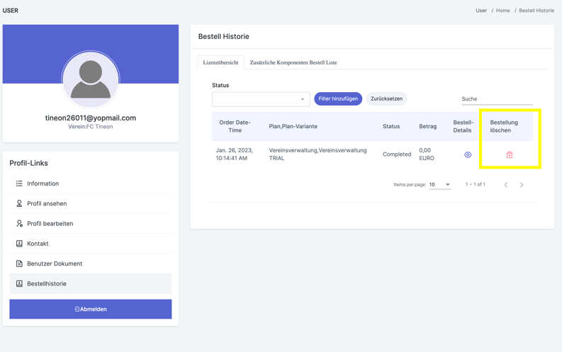

1. New HTML Mails (CRM)

Comment: Pending

New HTML Text for auto response at contact field (coming soon)

Ein Bild, das Text enthält.

Registration and verify mail (verification.html)

Installation with access data for club administration (access data.html)

1. New HTML Mails (VC)

Comment: Pending

Registrierung Community (coming soon)

Registrierung Member Light (coming soon)

1. The thumbs up and down should be linked to one question and not at the whole category.

Comment: Fixed

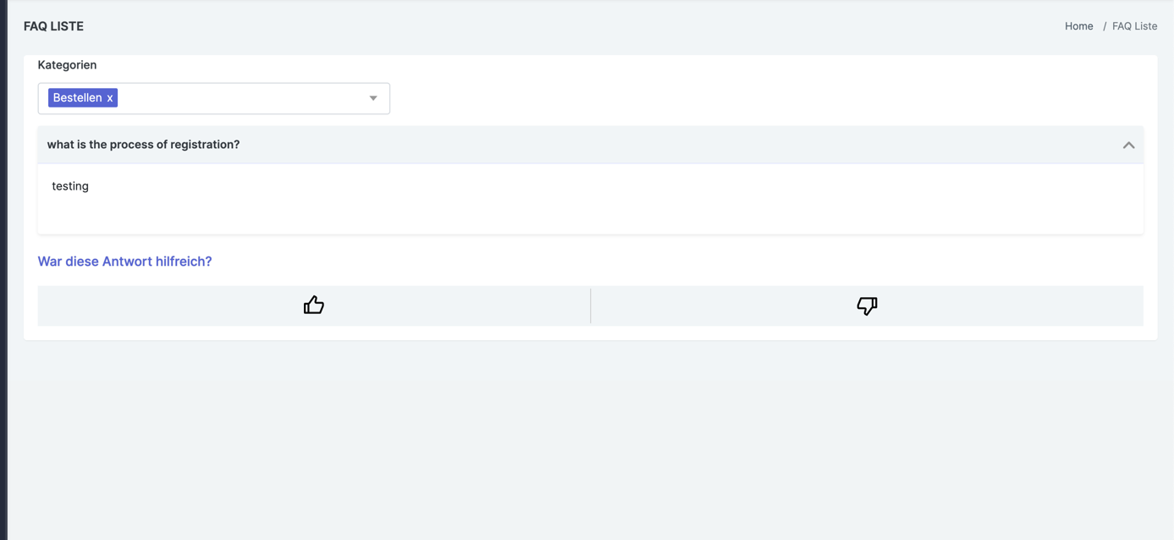

1. Ticketing

I am logged in as an admin and I am answering to the ticket, but my answers do not show up in the history this is a bug.

Comment: Fixed

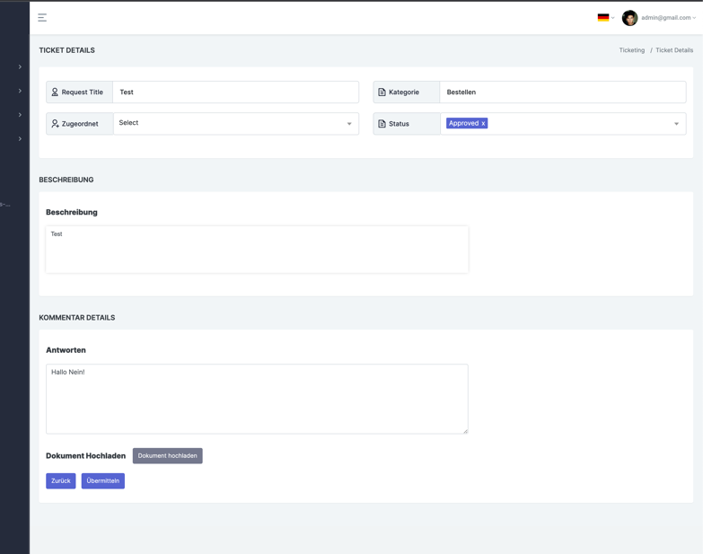

Ein Bild, das Text enthält.

Also I am not able to close the ticket or change the status.

1. It is possible to order without setting all the checkboxes this should not be possible!!!

Comment: Fixed

Ein Bild, das Text enthält.

1. At the order process at fulfilling the personal information the system is frezed with the loading screen.

Comment: As we are not getting replicated this issue on our end. So, can you please send that again in video format.

After a time it says “Payment transaction already in progress”

1. It appears In English
2. What does that mean?

Ein Bild, das Text enthält.
Ein Bild, das Text enthält.

1. Error in order process

After the order failed with the message “Payment transaction already in progress” it stopps.

But the product has been ordered at billwerk. Why?