Sales partner provision

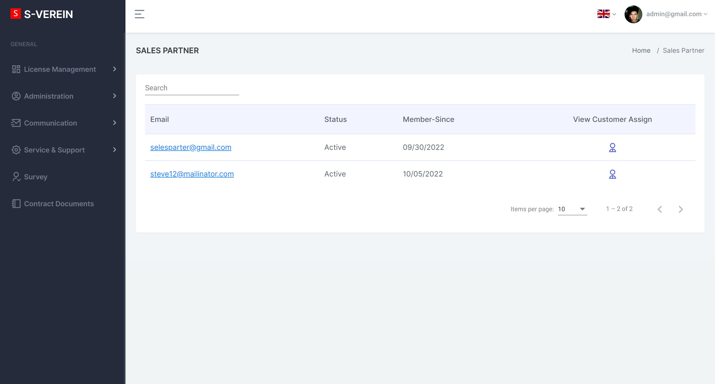

If you click on any sales partner we need to display different pages than with normal users (customers).

Ein Bild, das Tisch enthält.
The red marked field displays the assigned customers.

We need a second field like the assigned customers. Here a Tineon employee is able to set the unique settings for each sales partner. Here we talk about a commission the sales partner gets for each product one of his assigned customers buys.

We need to display all the available products in a list. With the product we need to show the price net and gross. Behind this we need a empty field to fill. Here a Tineon employee is able to fill in a number. The last field should be a selection field either for “€” or “%”.

Below the products we need a selection on how often the commission should be calculated. The selection should hold either “monthly”, “quarterly” and “yearly”. Also we need a start date field, where we are able to set the date of the start of the calculation of the commission.

Behind this selection we need to calculate the amount of commission using the number of assigned customers. The bought products of the customers and the amount of commission selected.

Example:

Salespartner A has 32 assigned customers.

32 Customers bought the club administration software, additional to the club administration 12 of them have also bought a financial software.

Commission table

|  |  |  |
| --- | --- | --- |
| Product | Price gross | Commission in € |
| Club Administration | 13,90€ | 2€ |
| Financial software | 29,90€ | 4€ |

The commission will get calculated quarterly:

(32 * 2€ * 3Months) + (12 * 4€ * 3 Months) = 336 € per quarter.

Salespartner B has 106 assigned customers.

106 Customers bought the club administration software, additional to the club administration 44 of them have also bought a financial software.

Commission table

|  |  |  |
| --- | --- | --- |
| Product | Price gross | Commission in % |
| Club Administration | 13,90€ | 10 % |
| Financial software | 29,90€ | 5 % |

The commission will get calculated yearly:

(106 * 13,90€ * 0,1 * 12Months) + (44 * 29,90€ * 0,05 * 12 Months) = 2557,44 € per year.

It is also possible to mix the calculations with % and €.