**Contribution management**

Create, bill and collect contributions easily and flexibly.

Every association has different contributions and the big problem is usually to set them up correctly in the association software. Each software usually has only limited functionality and is also complicated, so you need help to set it up so that you can map your contribution structure. We want to make that easier. The contribution builder guides you through each section. All the information is given to you clearly and simply, so you can also use the test area to see if you have set everything up correctly. This makes it very easy for us, as sellers of the software, to show you that we have thought along. The area is even subdivided in such a way that you can create articles that are sold as a recurring product as a contract, just like a sponsorship. After creating, allocating and invoicing, you can then quickly send out the invoice by mail or by post so that it reaches the addressee.

What if...

you could map your contribution structure 1:1

you could have premium adjustments automatically adjusted

you could also have your electricity bill calculated automatically.

you can include your own fields in the calculation.

**Contributions and direct debits**

Shows an overview of all contributions, open invoices and direct debits that need to be executed.

- Due contributions with quick selection for execution

- Overview of due and overdue contributions

- Direct debits that need to be executed

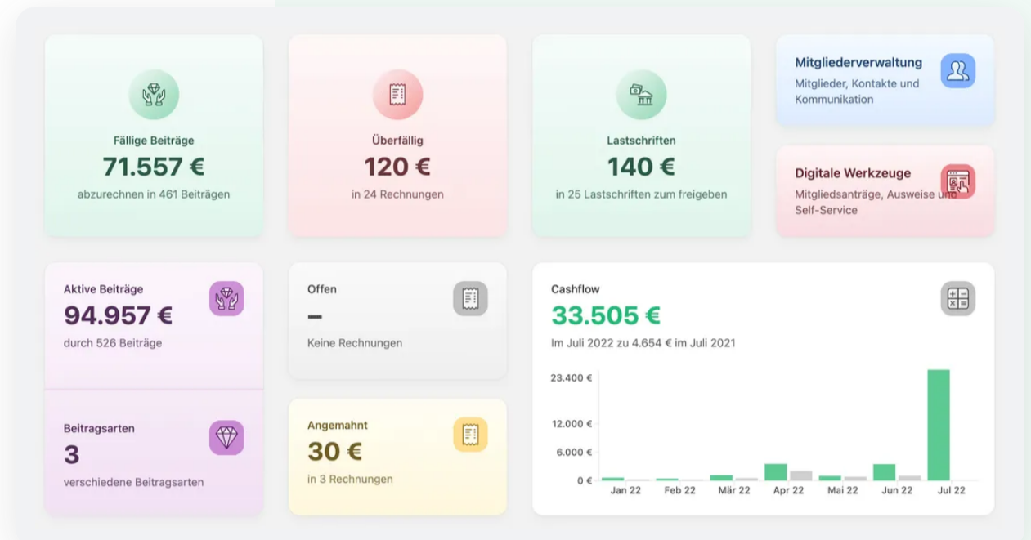

**Contributions as desired**

The contribution structures are different in each association. That is why we need a contribution editor.

- Contributions, donations and e.g. rental agreements

- One-off and recurring contributions

- Preview function with members

Ein Bild, das Text enthält.

**Accurate billing**

Running times and billing modalities can be perfectly coordinated so that no wishes remain unfulfilled.

- Individual interval, e.g. from June to December

- Billing and payment dates can be determined

- Individually determinable, pro rata billing for entry/exit in the current interval

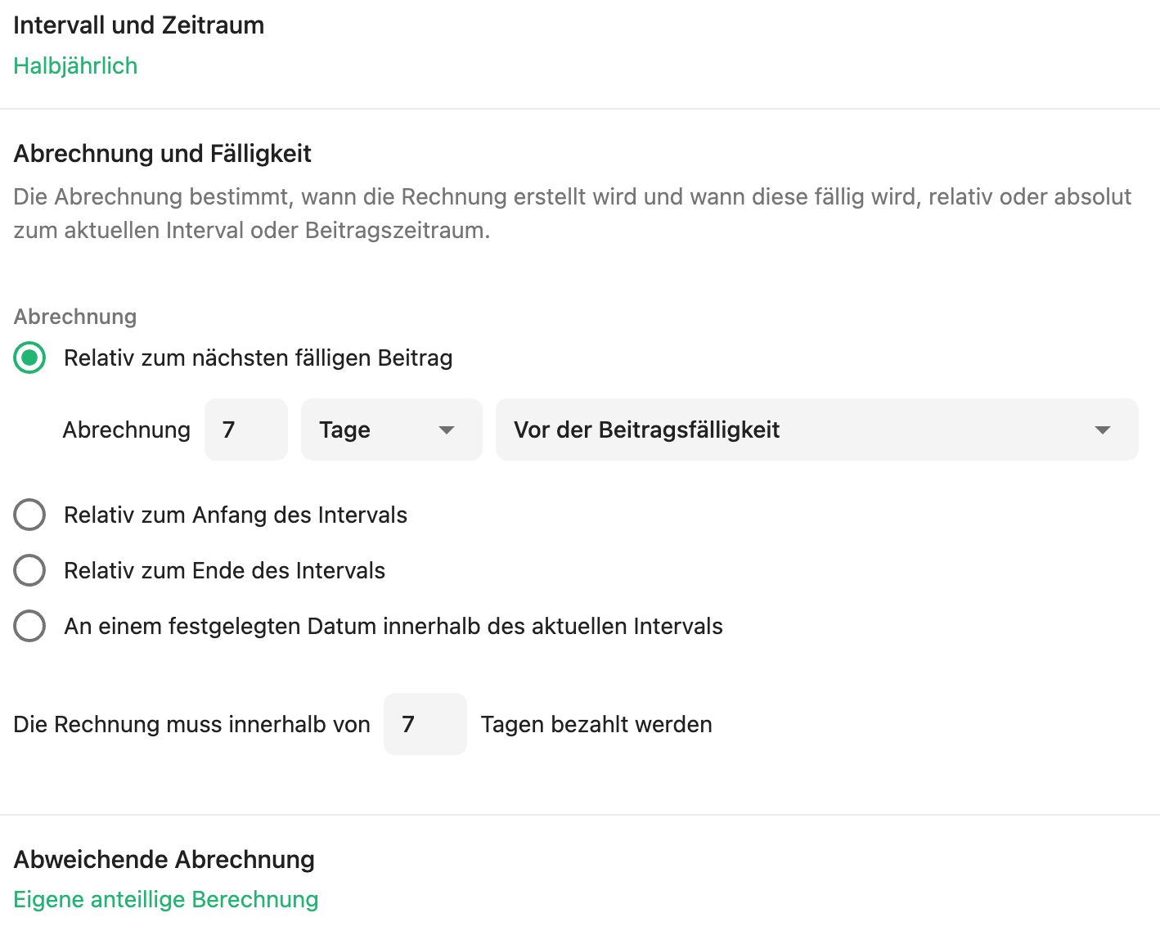

**Flexible contributions**

You can define exactly how the contributions are to be calculated and the system will then do it for you fully automatically.

- Contribution with booking account and pro-rata calculation

- Options can be added individually by member

- Own fields for calculation, e.g. for water consumption

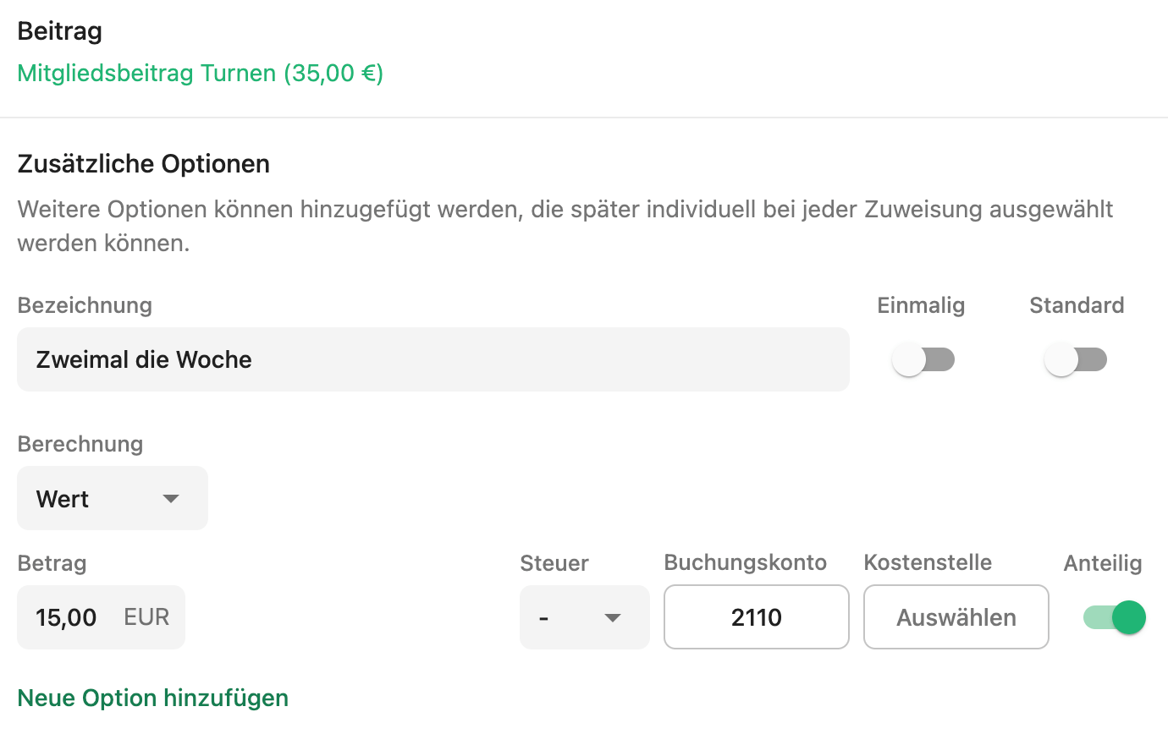

**Not every contribution is the same**

Adjustments make contributions so flexible that several can be combined into one contribution to save considerable administrative effort.

- Adjustments by age, day, length of membership, department, contribution period and custom fields.

- Offset, set new amount and more

- Each adjustment is reflected in the invoice

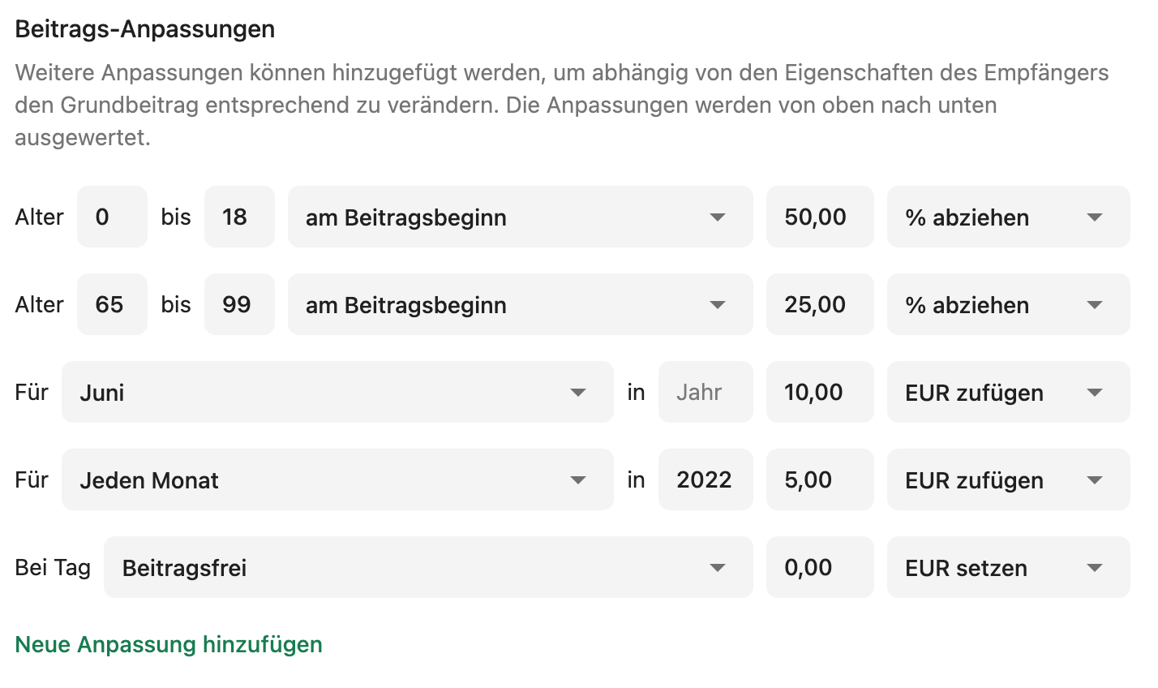

**Assignment made easy**

Easily allocate contributions and individualise them per member.

- Select individual options per member or set your own amount completely

- Complete preview of the statement

- Automatic calculation on termination and resignation

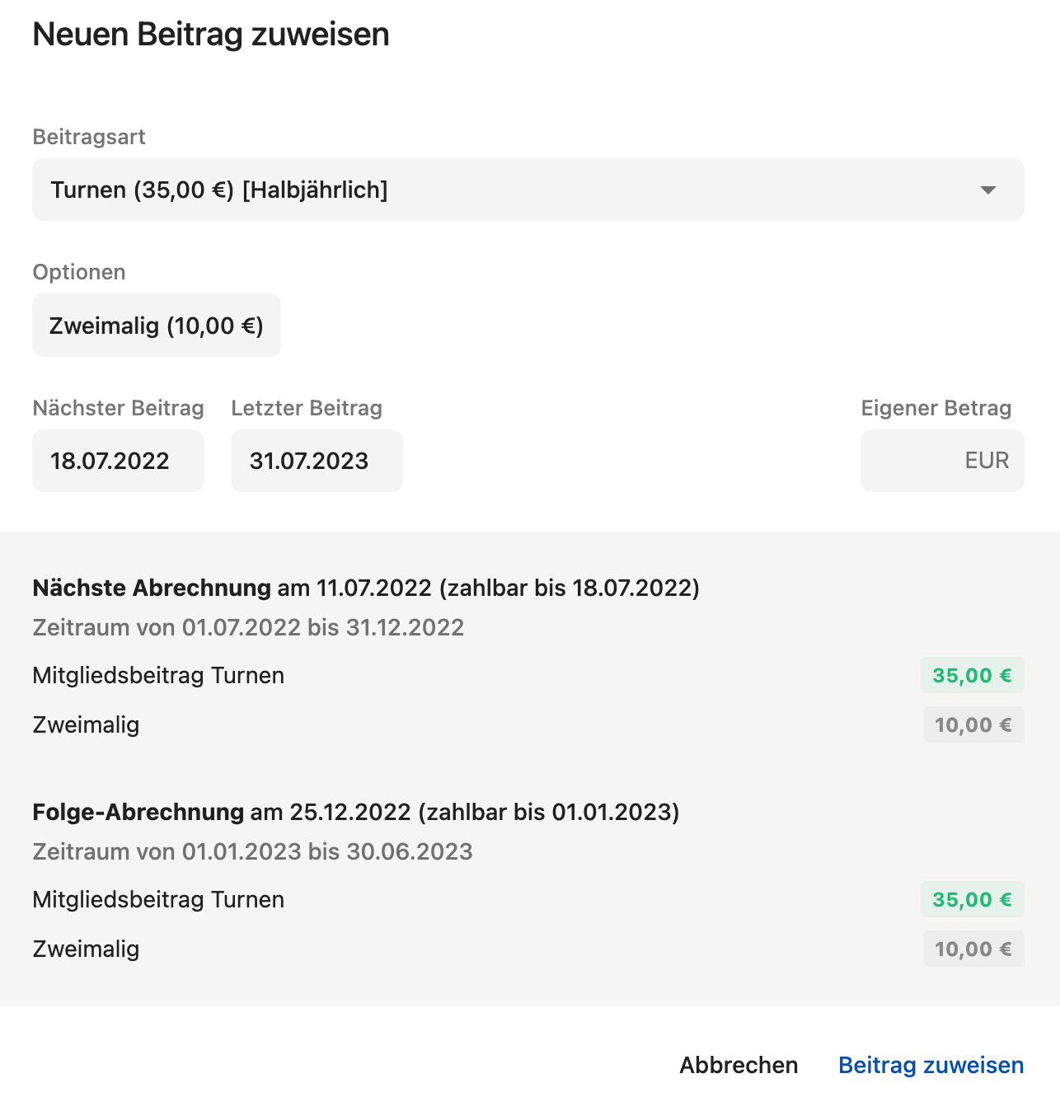

**Collect contributions**

Collecting and collecting different contributions with different due dates is child's play.

- Precise prediction of when which contributions must be collected and corrects any errors.

- Settle all or individual contributions in the overview list with one click

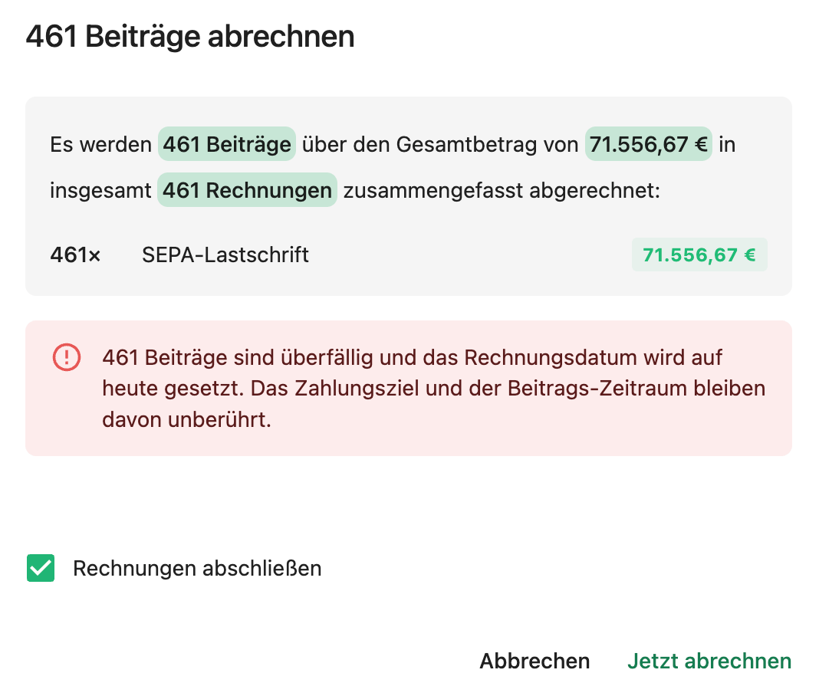

**Master direct debits**

Manage direct debits and returned direct debits easily via online banking and keep an overview.

- Submit via online banking or SEPA-XML

- Keep track of successful and failed direct debits

- Return direct debits and new claims quickly created with one click

**More features**

**Summary**

Several members with the same payer are summarised in one bill

**Consumption billing**

Use own fields with formulas to easily calculate e.g. electricity and water consumption

**Intervals**

Any type of billing and contribution interval possible e.g. different school years

**Direct debit reconciliation**

Comparison of paid and failed direct debits via online banking